Steps to download and Install artifactory in Linux

[May 30, 2017](https://nallarameshreddy.wordpress.com/2017/05/30/steps-to-download-and-install-artifactory-in-linux/) [nallarameshreddy](https://nallarameshreddy.wordpress.com/author/nallarameshreddy/)

**Purpose:**

* This blog shows how to download and Install artifactory as a service on a linux machine

**Pre-Requisites:**

* A Linux development machine with sufficient CPU, memory, and hard disk space.
* JDK 8 installer – for the demo I am using **jdk-8u92-linux-x64.tar.gz**

**Installing the JDK:**

* Java can be downloaded from – <http://www.oracle.com/technetwork/java/javase/downloads/index.html>
* For Linux download the installer and unzip it to preferred location.

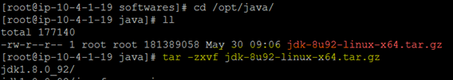

* Move to the extracted directory and use command **update-alternatives** to tell system where java and its executables are installed.

|  |
| --- |
| *update-alternatives –install /usr/bin/java java /opt/java/jdk1.8.0_92/bin/java 100 update-alternatives –config java* |

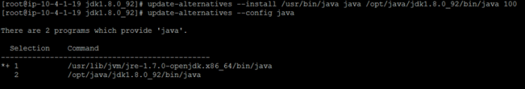

|  |
| --- |
| *update-alternatives –install /usr/bin/javac javac /opt/java/jdk1.8.0_92/bin/javac 100 update-alternatives –config javac* |

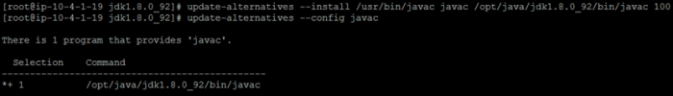

|  |
| --- |
| *update-alternatives –install /usr/bin/jar jar /opt/java/jdk1.8.0_92/bin/jar 100 update-alternatives –config jar* |

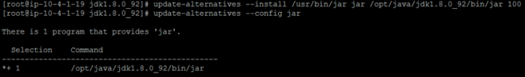

* After installation check the java version as in below snapshot.

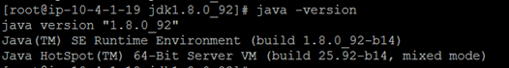

**Download and Install artifactory:**

* Download the rpm repo file and install artifactory. See <https://www.jfrog.com/confluence/display/RTF/Installing+on+Linux+Solaris+or+Mac+OS>for more information.

|  |
| --- |
| *wget*[*https://bintray.com/jfrog/artifactory-rpms/rpm*](https://bintray.com/jfrog/artifactory-rpms/rpm)*-O bintray-jfrog-artifactory-rpms.repo sudo mv bintray-jfrog-artifactory-rpms.repo /etc/yum.repos.d/ sudo yum install jfrog-artifactory-oss* |

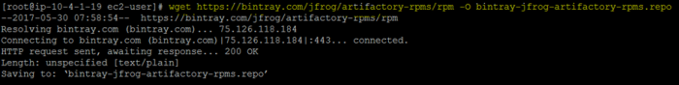

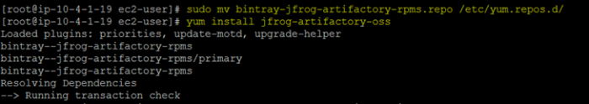

* Create a symbolic link to the Artifactory installation

|  |
| --- |
| *cd /opt/app ln -s /etc/opt/jfrog/artifactory/ /opt/app/artifactory* |

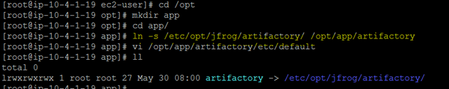

* Start Artifactory.

|  |
| --- |
| *sudo service artifactory start* |

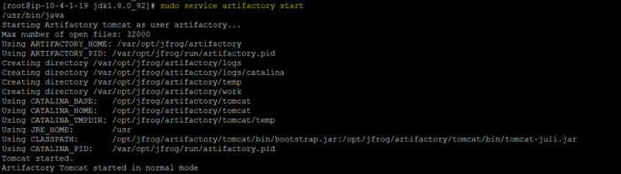

* To access the artifactory open the link : <http://host:8081/artifactory>

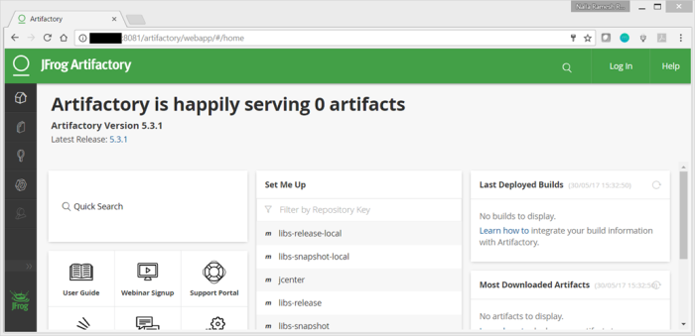

* When you access the above URL for the first time, it prompts for setting a password. Set a password of your choice.
* Add maven remote repositories.

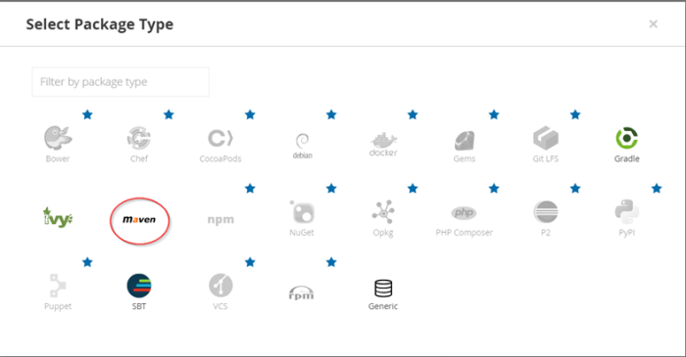

Go to your browser and visit IP_ADDRESS:8081 to visit Artifactory in the browser:

Login — default username password — admin/password

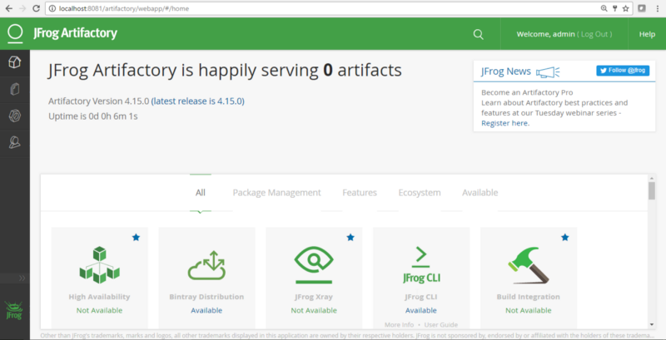

Create a Local repository to store package files created by the Jenkins project:

Click on Admin -> Repositories ->Local

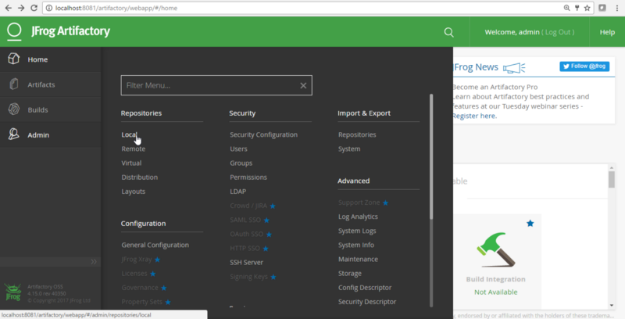

Click on New:

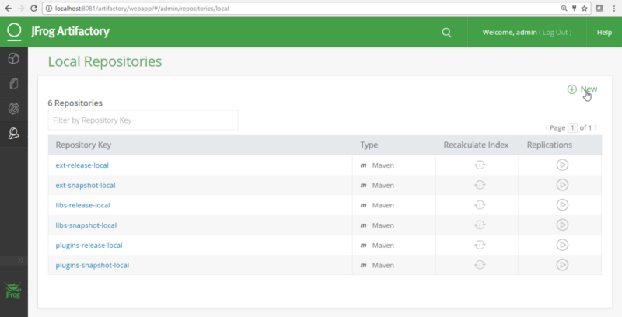

Select Maven as a Project Type:

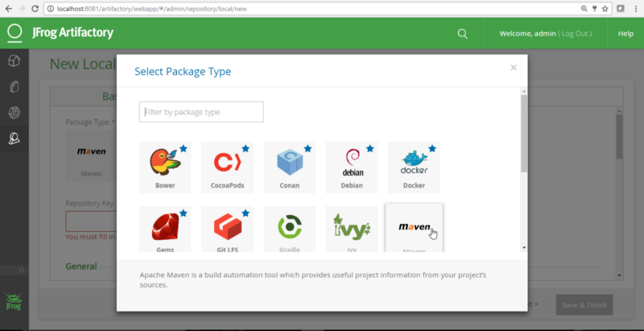

Give a Repository Key “jenkins-release” and click on Save and Finish:

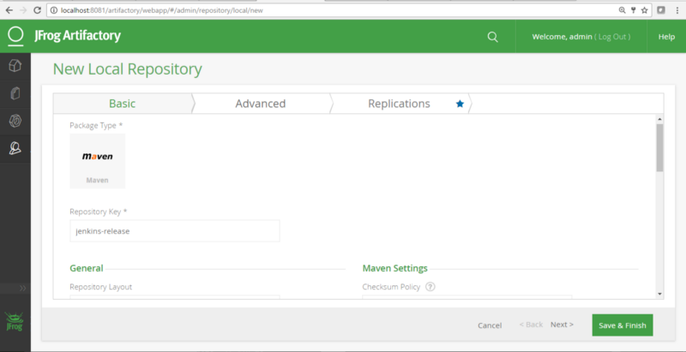

Similarly, create a Jenkins-snapshot repository:

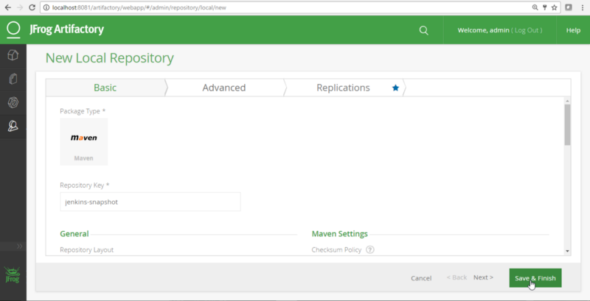

Verify all repositories in the list:

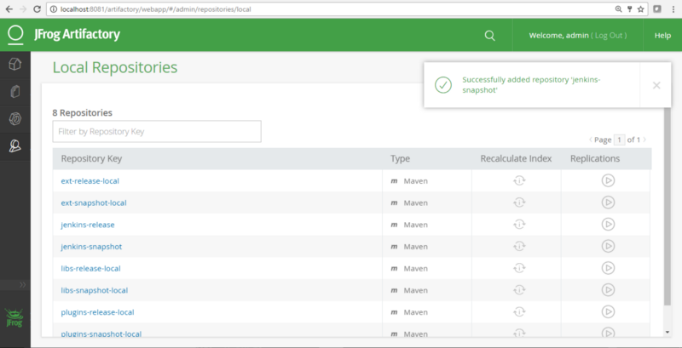

Create a user that you can utilize from Jenkins to access Artifactory:

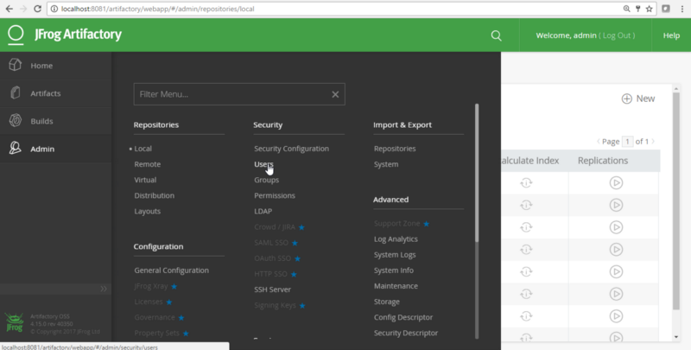

Click on New:

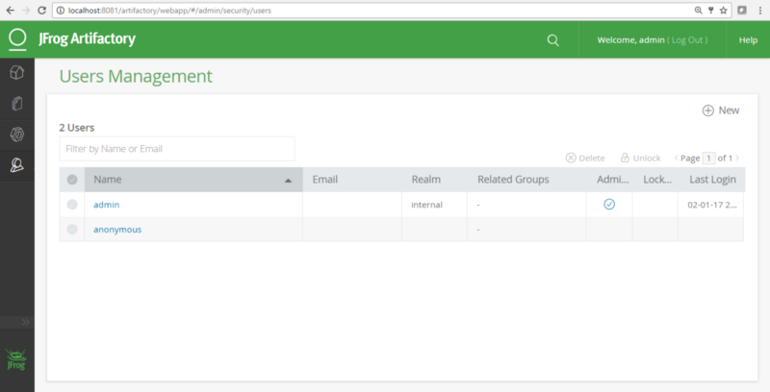

Provide user details and Save:

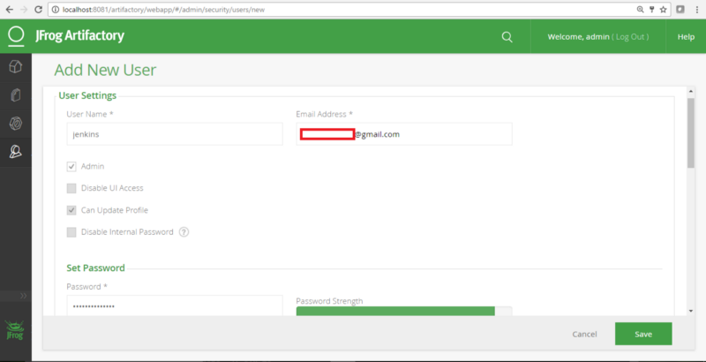

Verify the list of users:

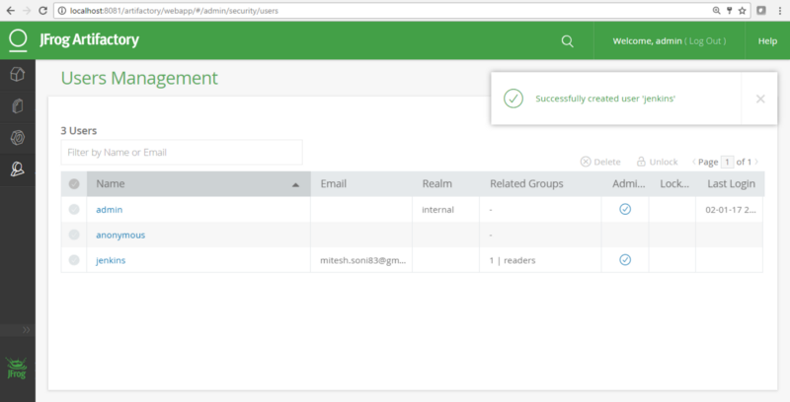

Provide the newly created user with permissions to the repositories:

Security -> Pemissions

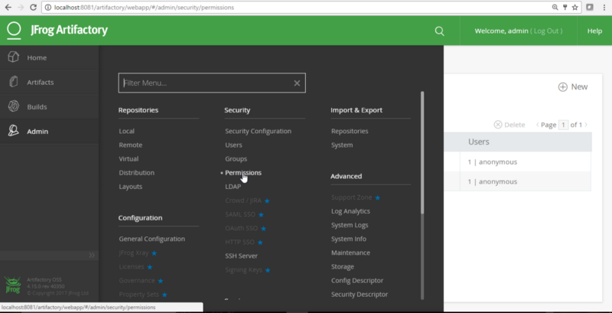

Create a new permission “jenkins-permission”

Select Repositories and click on Save & Finish:

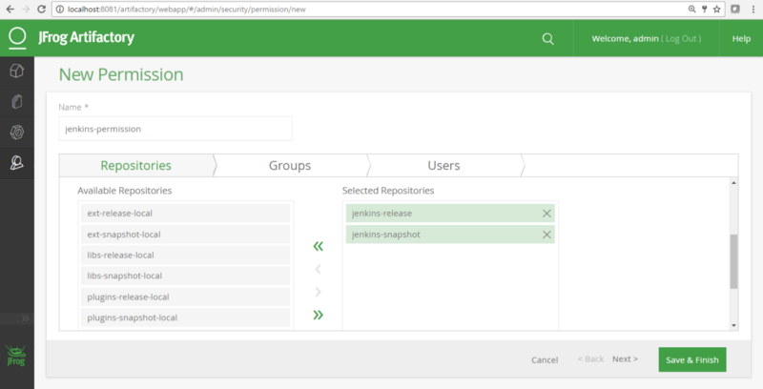

Check the Permissions Management section in Artifactory for recent changes:

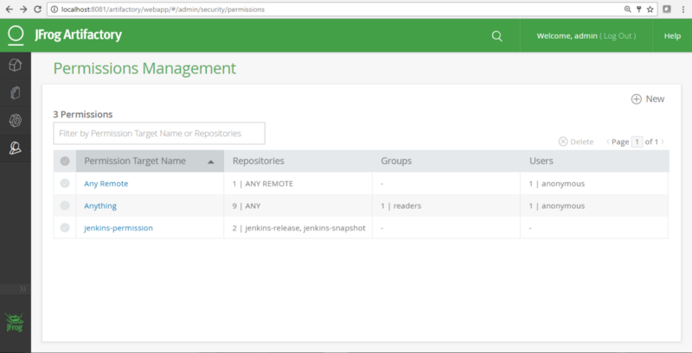

Edit the permissions and assign the user: If user is already admin then it has all permissions

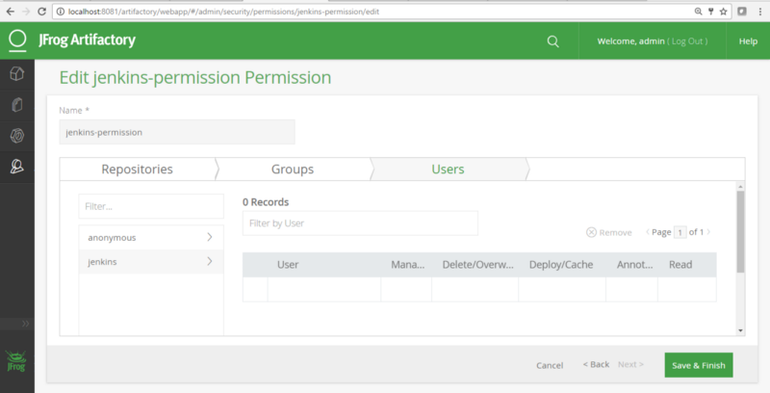

Click on Save & Finish:

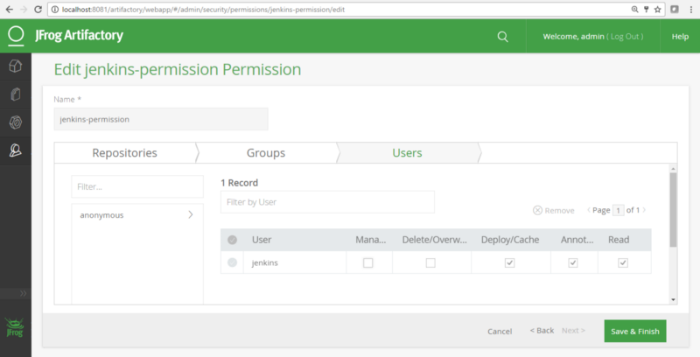

Check the Permissions Management section in Artifactory for recent changes:

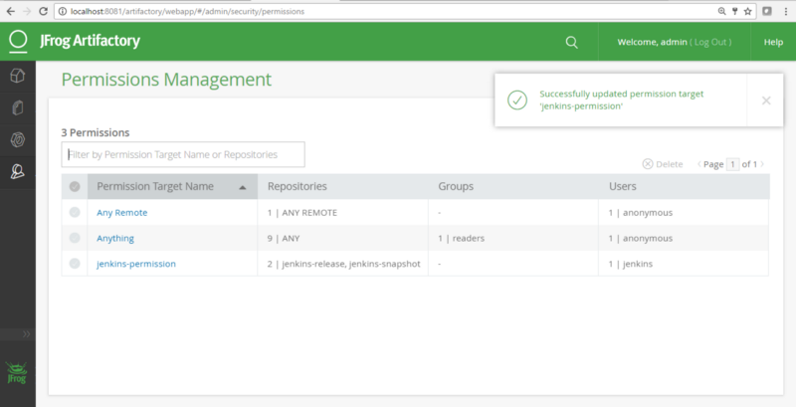

Jfrog setup is complete

* [Artifactory](https://medium.com/tag/artifactory?source=post)